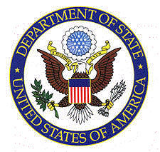
CONSULATE GENERAL OF THE UNITED STATES
LEVEL 59 MLC CENTRE 19-29 MARTIN PLACE SYDNEY NSW 2000
61-2-9373-9200 sydney.usconsulate.gov/sydney

PLEASE FOLLOW THIS CHECKLIST SPECIFICALLY FOR SYDNEY.
DO NOT FOLLOW KCC’S CHECKLIST.

Prepare the documents below as it is listed. Place photocopies directly beneath the original documents. DO NOT PLACE ORIGINALS IN ONE PILE AND THE COPIES IN ANOTHER. You are to present your appointment letter to the Visa Clerk upon your arrival to the immigrant visa unit at the U.S. Consulate General, Sydney. The documents must be out of envelopes or sleeves.

For Families: the spouse and children’s documents must be separated and put together in their own individual piles.

1. One recent photograph. It must be recent & not the same used for your entry application. Please refer to instructions on Page 2.
2. Valid passport and photocopy of its biographic page.
3. Education or Employment records and one photocopy each.
4. Original Birth Certificate, original English translation, if applicable and one photocopy of each.
5. For minor children immigrating with one parent: Original court order verifying sole custody to the immigrating parent or a signed and dated affidavit from the child’s other parent advising of his/her knowledge and consent for the child to live in the United States which should include a copy of a photo ID of that parent, or a death certificate of the other parent. Submit original and one photocopy.
6. Original Adoption decree or evidence of name change when applicable, original English translation, if applicable & one photocopy of each.
7. Original Divorce or Death certificate, original English translation if applicable & one copy each.
8. Original Marriage certificate, original English translation if applicable & one photocopy of each.
9. Original Australian police certificate & original police certificates of other countries if applicable, original English translation if applicable & one photocopy of each. To obtain instructions of police certificates from other countries, please refer to website: http://www.travel.state.gov/visa/reciprocity/index.htm Click on the alphabet of the country and scroll down to Police Records.
10. Original Court Records if applicable, original English translation if applicable & one photocopy each
11. Original Military Record if applicable, original English translation if applicable & one photocopy of each.
12. Evidence of your own assets or a notarized U.S. job offer or a notarized affidavit of support from a U.S. citizen or legal permanent resident domiciled in the United States. Determination of whether your assets may be acceptable will not be made until the day of your final visa interview. Form I-134 for an affidavit of support may be downloaded from website:
http://www.uscis.gov/files/form/I-134.pdf
13. Medical results.
14. All expired passports
15. Old/Expired/Invalid Alien Registration Card and Re-entry Permit if applicable.
16. Fee: USD$775.00 per visa applicant to be paid in cash, credit card, postal money
order or bank check made payable to the U.S. Consulate.
17. One 3kg self-addressed Express Post envelope, which will be used to mail you your visa.

IF THE DOCUMENTS ARE NOT IN ORDER YOU WILL BE ASKED TO TAKE A SEAT TO REORGANISE. YOUR CASE WILL THEN BE PLACED AT THE END OF THE QUEUE.

Format for photographs:
- Frame subject with full face, front view, eyes open
- Make sure photo presents full head from top of hair to bottom of chin; height of head should measure 1 inch to 1-3/8 inches (25 mm to 35 mm)
- Center head within frame (see sketch below)
- Make sure eye height is between 1-1/8 inches to 1-3/8 inches (28 mm and 35 mm) from bottom of photo
- Position subject and lighting so that there are no distracting shadows on the face or background
- Encourage subject to have a natural expression

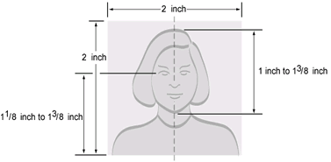
DV Pkt4 KCC Inclusion (05/22/07)

